Dashboard Overview:

Dashboard features:

1.Top 10 Product categories by total sales:

As per the question stated the top 10 product categories are visually depicted using a bar graph for simple illustration , the product table is linked to the orders dataset and the sum of price from the orders dataset is grouped by category names.
PFB the snapshot of the BI dashboard that shows the required data. A report table alongside the bar graph is to show the actual sales totals data for the category names.

Power BI dashboard page 1.1
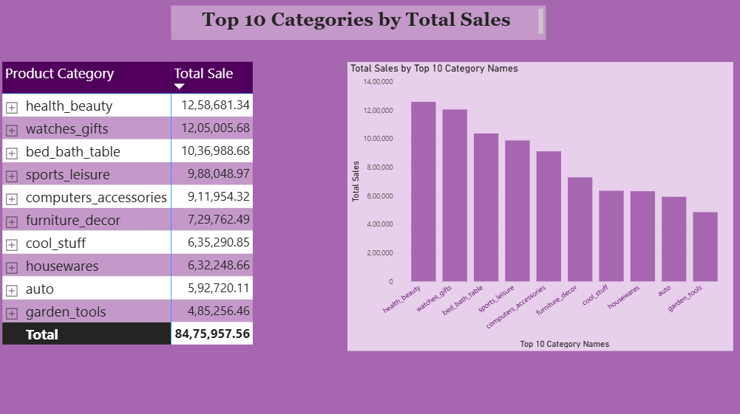

2. Delayed Order Analysis:

A matrix view is created to show the number of delayed orders vs not_delayed times along with the total number of orders delivered in a product category wise view.
A slicer button is also available to toggle between delayed and not_delayed orders.
PFB a snapshot of the dashboard view for the same.

Power BI dashboard page 1.2
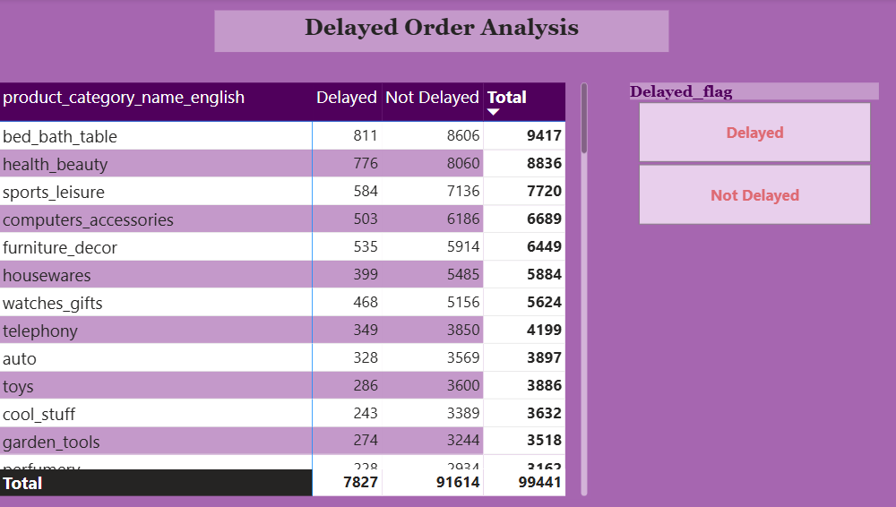

3. Month wise delayed order analysis:

A matrix view is created to show the monthwise delayed vs early delivered orders, the drill-through cross report feature is enabled for the date field to explore yearly , quarterly , monthly and daily split of the same. Two slicers are provided on the right to choose the year, quarter or month and another for delayed and early orders.
PFB a snapshot of the dashboard view for the same.

Power BI dashboard page 1.3
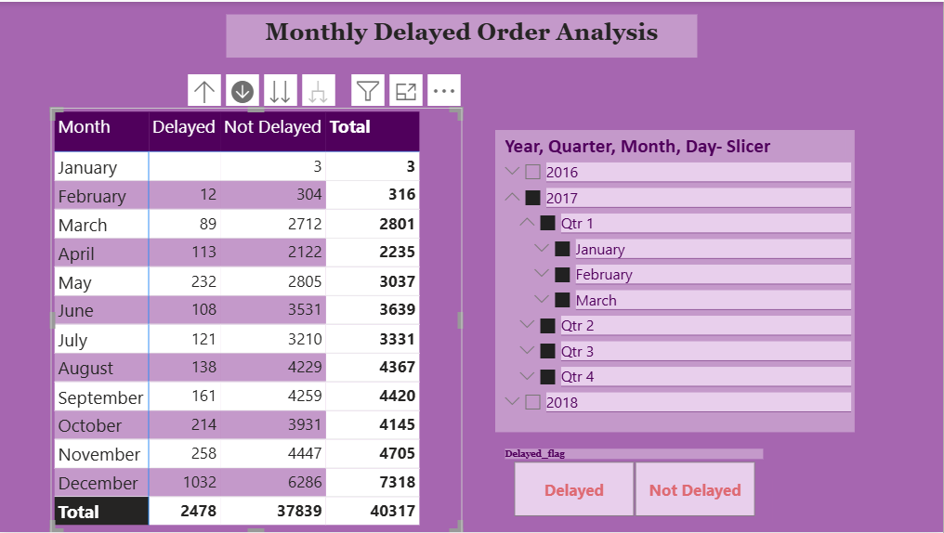

4.Payment Method analysis:

The various payment methods used by customers are displayed visually using a donut chart and the actual numbers are displayed in matrix view alongside.
A timeline slicer is provided to view data for different periods of time.
PFB a snapshot of the dashboard view for the same.

Power BI dashboard page 1.4
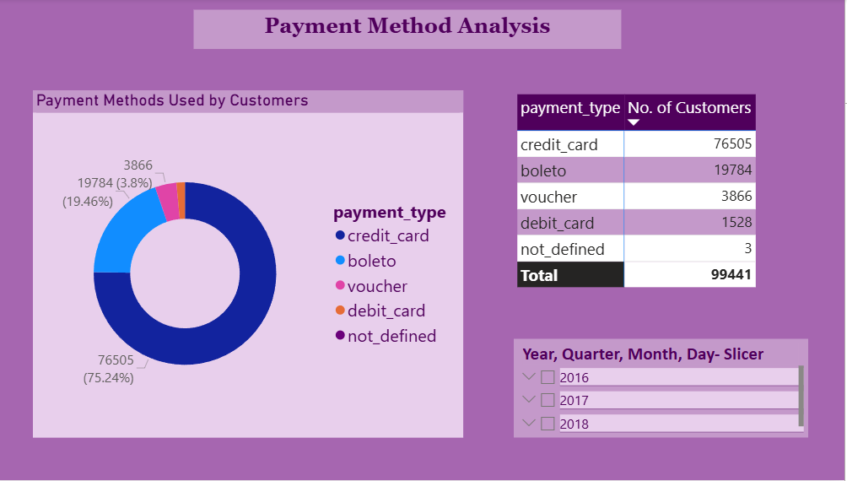

5.Product Rating Analysis:

The top 10 highest rated categories and the bottom 10 lowest rated categories are displayed using a bar chart in this slide. A new measure is created to rank the top 10 and bottom 10 categories and used in the x-axis and another measure for colour formatting of the columns in the chart.
PFB a snapshot of the dashboard view for the same.

Power BI dashboard page 1.5
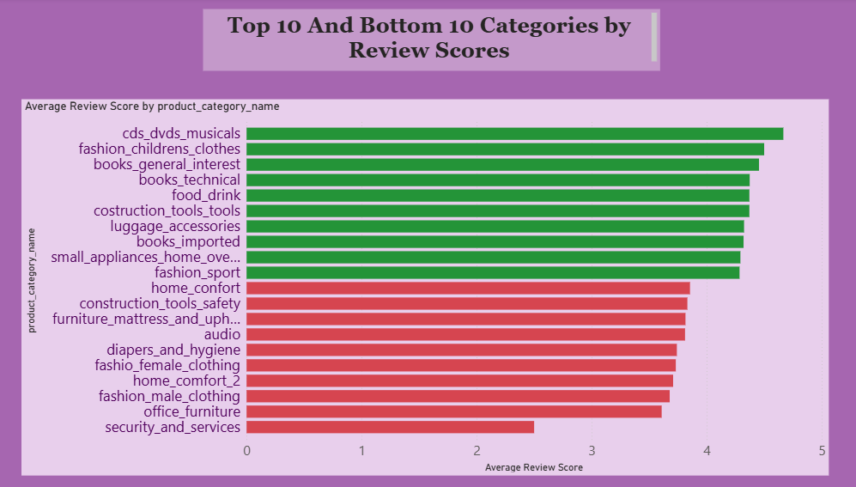

6. State- wise sales Analysis:

To visually represent the states with high and low sales a map chart and scatter chart are used with bubble sizes indicating high and low sales volumes . A couple of cards are added with the total revenue and total quantity of orders for more understanding of the data.
A timeline slicer is provided to view data for different periods of time.
PFB a snapshot of the dashboard view for the same.

Power BI dashboard page 1.6
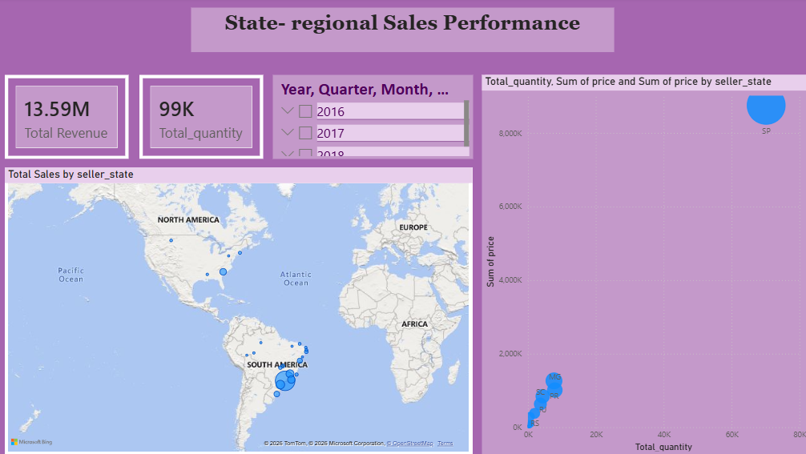

7. Seasonal Trend Analysis:

Monthly order volume trend is depicted by the combo bar-line chart which shows the order volume and total revenue generated each month has a linear relationship. We can also see the seasonal trend in order volume in the total orders by season area line chart which shows summer and spring have the highest order volume, due to European festivals that happen in summer and spring seasons , there is also a spike in orders in November and December months due to popular holidays like Christmas . A stacked column chart is used to show the top 10 categories’ order volumes seasonally.
A timeline slicer is provided to view data for different periods of time and a season slicer is provided to deep dive into individual seasons.
PFB a snapshot of the dashboard view for the same.

Power BI dashboard page 1.7
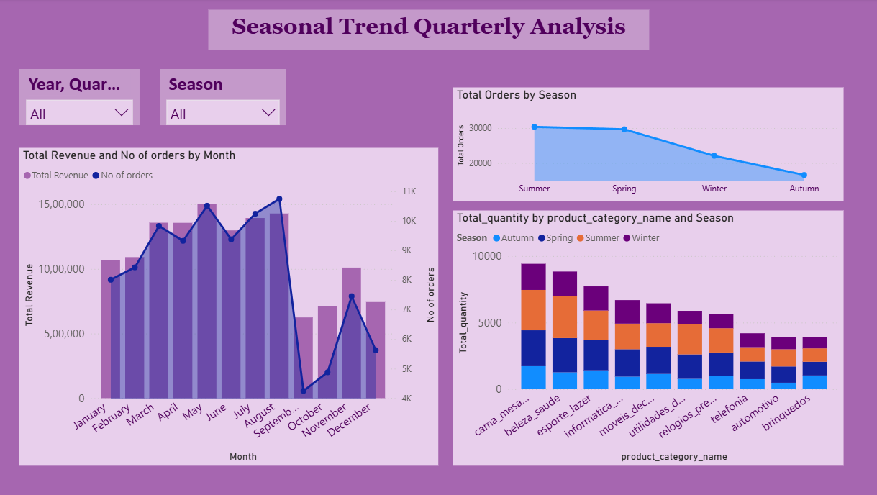

8. Revenue Analysis:

The yearly revenue with the order volume is depicted by the combo bar-line chart which shows the order volume and total revenue generated each each year has a linear relationship. The AOV and the order volume have an inverse relationship as AOV seems to be reduced by a margin with increase in order volume year on year . The various payment methods used are shown in the colourful legends , credit cards are seen to be the most popular choice of payment by customers year on year .
PFB a snapshot of the dashboard view for the same.

Power BI dashboard page 1.8
